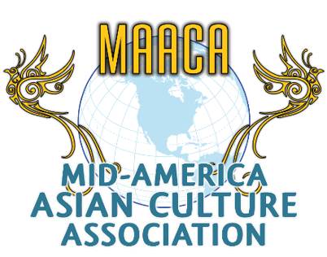 | Youth Club of MAACA  Registration Form

Our Mission: The Youth Club of MAACA was made to inspire and empower youth. We are a group of youth leaders who come together and think up of ideas and how to carry them out. We are making the new youth generation where the youth have an important role in the world.

Youth Full Name _______________________________________________________________
Parent/Guardian Name: ________________________________________________________
Date of Birth: ______________ Age: ________ Gender: _________ Grade: ____________
Address: ______________________________________________________________________
City: _______________State: _____________ Phone:___________________________
Email: ________________________________________________________________________
Ethnicity (For example, Native American, Hispanic, White American, Asian American)
___________________________________________________________________________

Things that you are proud of doing/Awards: __________________________________________________________________________________________________________________________________________________________________________________________________________________________________________
Hobbies: ______________________________________________________________________
MAACA Contact: board@maacaweb.org.
Youth Signature:

